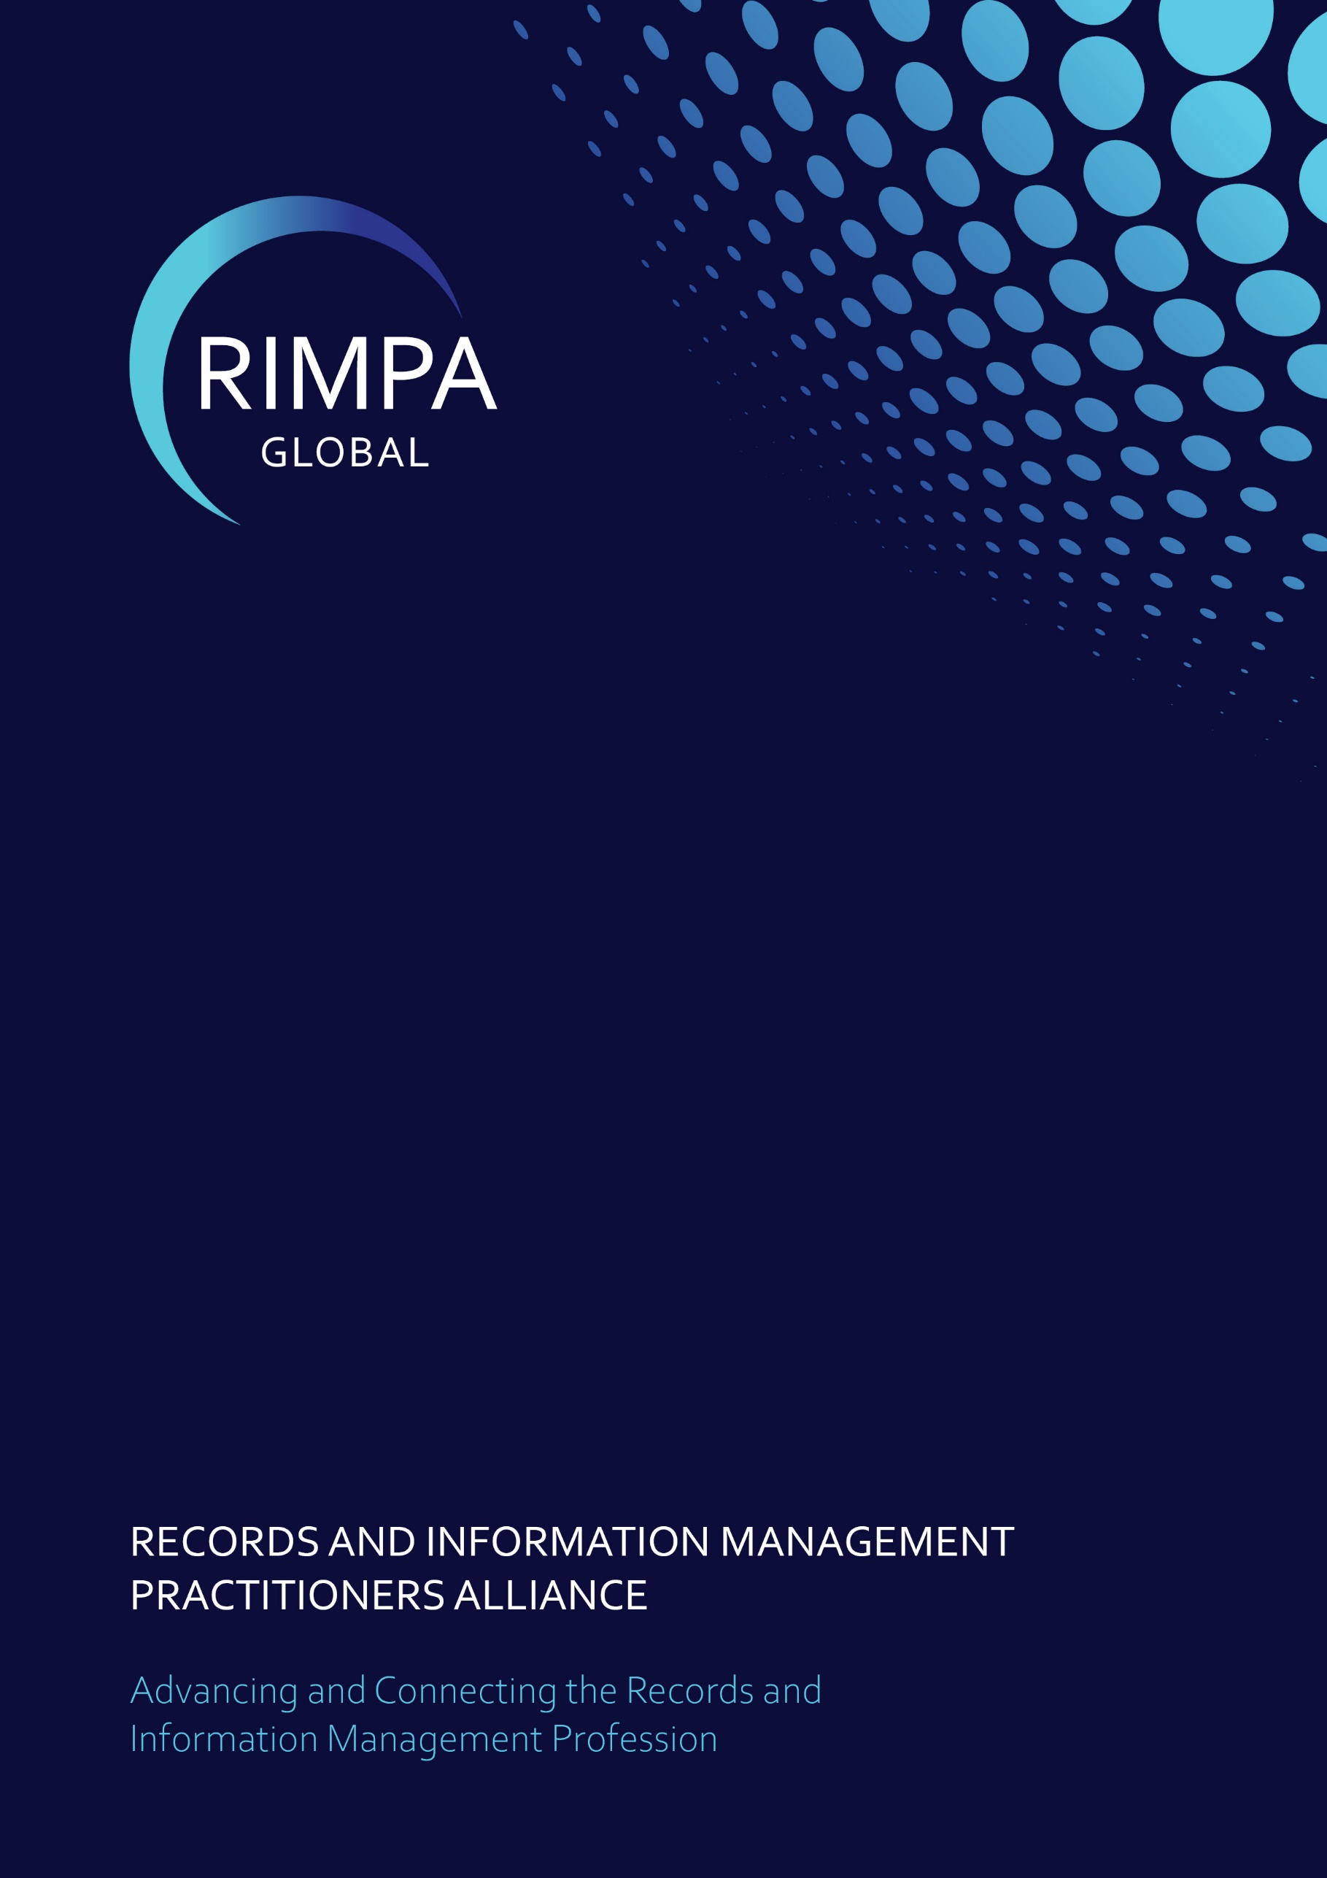
RIMPA Elected Director Position Description

ROLE OVERVIEW
As an Elected Director, you will bring your expertise and insights to shape the future of RIMPA Global. In this influential role, you’ll contribute to the governance, strategic direction, and overall performance of the organisation, while ensuring the mission aligns with member value and industry growth.

KEY RESPONSIBILITIES
As an Elected Director, your contributions will include:
- Shaping and guiding the governance and strategic direction of RIMPA Global.
- Monitoring the operational and financial health of the organization.
- Driving performance and initiatives that deliver measurable value to members.
- Identifying and managing risks to ensure sustainable growth.
- Overseeing the performance of the CEO and providing strategic support.

REQUIRED SKILLS AND CRITERIA

To perform this role, you will need:
- Proven eligibility and experience in strategic planning.
- Expertise in industry-relevant fields
- Strong personal attributes, including the ability to inspire and collaborate effectively.

4 REPORTING AND ACCOUNTABILITY

As an elected director you will be responsible strategic initiatives that are executed and evaluated in line with governance requirements.
This includes:
- Regularly updating the RIMPA Board on progress related to your area of strategic responsibility.
- Ensuring compliance with policies, procedures, and relevant regulations.
- Evaluating the impact and success of initiatives against RIMPA’s strategic goals.
- Collaborating closely with other board members to align initiatives with RIMPA’s mission.
- Maintaining open communication with stakeholders, including members and industry partners, to gather feedback and provide updates.

5 Board powers
The board has the authority to:
- Undertake activities as defined in the Constitution and the Act.
- Delegate responsibilities to Directors, the CEO, committees, or employees.
- Create or dissolve committees, working groups, and communities of practice.
- Establish subcommittees and delegate powers as needed.
- Appoint or remove officers, including the CEO, according to contractual terms, delegation register and the Board Charter.

6 TIME COMMITMENT
This role is estimated to require the following time commitment each year:
- Attendance at RIMPA Live and Board Meeting (7 days, September/October).
- One other in-person Board meetings (1 day, plus travel).
- Four to six virtual Board meetings (2.5 hours each).
- Advocacy efforts (approximately 10 hours).
- Representation at non-RIMPA GLOBAL events (16 hours).
- Stakeholder management (8 hours).
- Participation in Working Groups or Committees (14 hours).

7 ROLE INCENTIVES

Elected Directors will not be out of pocket for RIMPA GLOBAL related activities and are to be reimbursed for associated costs when traveling or utilising own resources.
- Travel (flights, accommodation, taxis, or mileage).
- Equipment or stationery costs.
Additionally, as an Elected Director, you will enjoy:
- Complimentary access to all local RIMPA events.
- Paid attendance at approved external events while representing RIMPA Global.
- A fully paid ticket, up to seven nights’ accommodation, and flights to RIMPA Live.

Important note: This does not include reimbursement for loss of income unless otherwise agreed by the Board.

